Links to Early Learning Resources

20–Minute Math Ideas
- https://www.carriecutler.com/for-parents
"Families at Home: Essential Daily Routines"
- https://parents.britannica.com/families-at-home-essential-daily-routines/
IDEALS Institute Resources During COVID-19 Outbreak
- https://idealsinstitute.org/resources/
Social Story – Something Strange Happened in My City: A COVID-19 (understood by ages 3-8)
- https://sandybabaece.wixsite.com/covid19referencelist
Making Home Videos
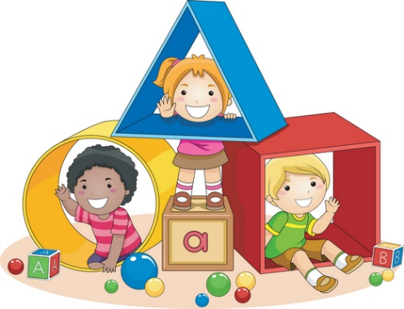
- "Making Videos at Home: Tips for Educators"
Peep and the Big Wide World (Math and Science)
- Peep and the Big Wide World
NAEYC Blog Posts
- Tips for Video Chatting with Young Children
NAEYC Blog Posts
- Creative Ideas for Playing with Grandchildren When You Can't be Together
Families at Home: Essential Daily Routines
- https://parents.britannica.com/families-at-home-essential-daily-routines/
Thoughts of Parenting and Beyond
- https://www.beautyinparenting.com/theblog
Eastern Region Association of Forest and Nature Schools (some are open to members only)
- http://www.erafans.org/free-online-learning

